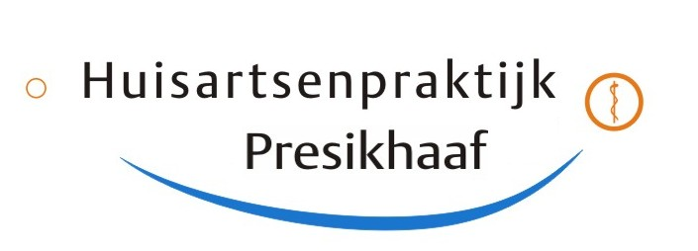

Informationletter Huisartsenpraktijk Presikhaaf

GP K. Bülbül

GP M.L. Bassa

GP F.A. Ali

Arnhem, December 2024

Dear Sir/Madam,

We would like to inform you about the changes in healthcare and in our general practice.

As a general practice, we face major challenges, including a changing healthcare landscape, a tight labor market, high expectations, an aging population, legislation and staff shortages.

In order to continue to provide good care in the future, we are making some changes. We need your help and understanding with this.

**Telephone contact**

· You can leave a callback request with a time slot between 8:00 AM and 10:30 AM. The doctor's assistants will then call you back.

· You will have a short waiting time and will be called back at a time that suits you.

· Would you still like to wait during these times? You will then hear how long the waiting time is. We advise you to only do this for very urgent matters.

**Privacy Desk**

To guarantee your privacy in accordance with the law, we have taken a number of measures:

· Patient data will no longer be discussed at the counter. This also applies to your name, address, date of birth and medical information.

· Would you like to make an appointment? Then we request that you call us. This way you can fully explain your situation and the doctor's assistant can make a better assessment.

· Do you have a question? Please submit this by telephone or digitally via MijnGezondheid.net (MGN).

· Delivery of a urine sample takes place via a short questionnaire on paper.

This means you do not have to discuss privacy-sensitive information at the counter.

We thank you very much for your cooperation and pleasant cooperation!

Kind regards

General Practice Presikhaaf

K. Bülbül, M.L. Bassa, F.A. Ali